**GIFT LOOP  
 (You give,They gain,We grow)**

*1Udhayakumar T, 2Sureshkumar A, 3Arunkumar R, 4Shahana R, 5Jayabharathi B,6Pabitha G*

*1,2Assistant Professor, Department of Computer Science and Engineering, Rathinam Technical Campus, Coimbatore-641021, India.*

*3,4,5,6UG-Students, Department of Computer Science and Engineering, Rathinam Technical Campus, Coimbatore-641021, India.*

**ABSTRACT**

“Gift loop" is an innovative unwanted stuffs management system designed to address the escalating global challenge of wasting good stuffs. This comprehensive solution integrates technology, community engagement, and sustainable practices to minimize goods wastage at various stages of the supply chain. Key components include a user-friendly mobile application that empowers buyers to make informed purchasing decisions, reducing the likelihood of excess things in households. This fosters partnerships with local charities enabling seamless redirection of surplus goods from businesses to those in need. Through real-time tracking and analytics, the system not only minimizes goods wastage but also creates a positive impact on communities by addressing poverty and promoting sustainable consumption.By decluttering our living spaces and donating items we no longer need, we not only create physical space but also foster a sense of purpose and community engagement. Through the act of donation, individuals contribute to the well-being of others, providing essential resources to those in need and supporting various charitable organizations.This abstract delves into the ripple effects of donating, examining how it fosters connections within communities and promotes a culture of giving. It highlights the significance of small individual actions in collectively addressing social and environmental challenges.

***keywords: Unwanted stuffs Management, User-friendly website, Real-time, Supply chain efficiency, Minimize poverty.***

**INTRODUCTION**

This project has potential and impact full in main streaming of needed peoples .Their basic needs are met and they will get new life through gaining knowledge ,vocational skills and life skills. The introduction of the “Gift loop“ increase the confidence level and become good asset to the community.This project was developed physically and psychologically and made as good and productive citizens.This introduction sets the stage for an exploration of the key features and benefits of the “Gift loop", highlighting its potential to revolutionize how we view and manage resources, promoting a more sustainable and socially responsible approach to nourishment. This will inspire by philanthropy and show humanity towards the community.In the modern era of consumerism, our lives are often filled with an abundance of material possessions. From clothing to electronics, furniture to kitchenware, we accumulate items at a staggering pace, often without realizing the impact of this accumulation on our homes, our communities, and the environment at large.

However, amidst this sea of possessions, there lies a powerful opportunity: the act of donating unwanted items. Donating provides a means to declutter our living spaces while simultaneously making a positive impact on the lives of others. Whether it's clothing that no longer fits, electronics that have been replaced by newer models, or household items that have outlived their usefulness, these unwanted possessions can find new life and purpose through donation.

**LITERATURE REVIEW**

The literature on unwanted stuffs donating management system reflects a growing concern about the environmental, economic, and social impacts of food waste. Researchers and experts in various fields have investigated different aspects of waste, including its causes, consequences, and potential solutions. Here is an overview of key themes found in the literature:

* **Extent and Causes of goods waste:**

With the growing frequency and quantity of clothing purchases, the elimination rate of waste clothing is increasing.  By the fast fashion trend, the consumption of clothing has increased greatly. Subsequently, the quantity of waste clothes has also increased.

* **Environmental Impacts:**

The donating unwanted items from homes offers a simple yet effective way to minimize waste, conserve resources, and mitigate environmental pollution, thereby contributing to a healthier planet for current and future generations.Donating items allows them to be reused and repurposed by others, thereby extending their lifecycle. This reduces the demand for new goods to be produced, conserving the natural resources

* **Economic Considerations:**

Donating unwanted goods can have significant economic benefits for individuals and society, including tax savings, cost reductions, social impact investment, job creation, and community development. By supporting charitable organizations through donations, individuals can make a meaningful contribution to both the economy and the well-being of their communities

* **Technological Innovations:**

.In donating unwanted goods have transformed the donation process, making it more efficient, transparent, and impactful. These innovations leverage the power of digital platforms, data analytics, and emerging technologies to streamline donation workflows, expand access to donation opportunities, and empower individuals and organizations to make a positive difference in their communities.

* **Policy and Regulatory Frameworks:**

Literature emphasizes the role of government policies and regulations in supporting charitable giving, consumer protection, environmental sustainability, and international cooperation. By establishing clear rules and guidelines, policymakers can facilitate the donation process and enhance the positive impact of charitable contributions on society.

* **Consumer Behavior and Awareness:**

Understanding consumer attitudes and behaviors related to are influenced by a variety of factors, including perceived value, social norms, convenience, incentives, and education. By understanding these factors and tailoring strategies to address consumer motivations and preferences, organizations can effectively encourage donation and maximize the benefits of charitable giving for individuals, communities, and society as a whole.

* **Social and Ethical Considerations:**

The social dimensions of donation, including donors and organizations can ensure that donations of unwanted goods contribute positively to individuals, communities, and society as a whole, while upholding principles of dignity, fairness, transparency, and sustainability.

* **Goods Recovery and Redistribution:**

Initiatives focused on rescuing and redistributing surplus goods to those in need are examined. Studies assess the effectiveness of goods recovery programs,their donation programs and strive to support initiatives that promote lasting positive change in communities.

* **Cross-Sector Collaborations:**

Collaboration between various stakeholders, including government agencies, businesses, non-profits, and the research community, is emphasized as essential for developing and implementing effective goods waste reduction strategies.

In conclusion, by giving away the things you don’t need to people who can see potential value in your stuff, you’re helping others and positively impacting the environment. From reducing waste and conserving natural resources to providing essential items for those in need and strengthening the local community, the benefits of donating are many and far-reaching.

Whether you donate to a local charity, non-profit organization, or community center, every donation can make a difference. So, the next time you find unwanted items, consider donating them. Not only will you clear space in your home, but you’ll also positively impact the world.

**PROPOSED SYSTEM**

Developing a goods management system like “Gift loop" requires a comprehensive methodology to address various aspects of the project. Here's a proposed methodology.Project Definition and Scope, Market Research, User Requirements and Stakeholder Analysis, Technology Assessment, System Design, Prototyping and Development, Regulatory Compliance, Pilot Testing , Launch and Marketing, Continuous Improvement.This includes the mechanisms for ongoing monitoring and improvement of gift loop based on user feedback, technological advancements, and changing regulations.By following this proposed methodology, we can systematically develop and implement gift loop, contributing to effective goods management.Encourage businesses to establish donation programs for their employees and customers. Companies could provide incentives for employees to donate unwanted products, such as paid volunteer time or matching donations. Businesses could also organize donation drives or establish partnerships with local charities to facilitate the collection and distribution of donated goods.

**DATA PROCESSING**

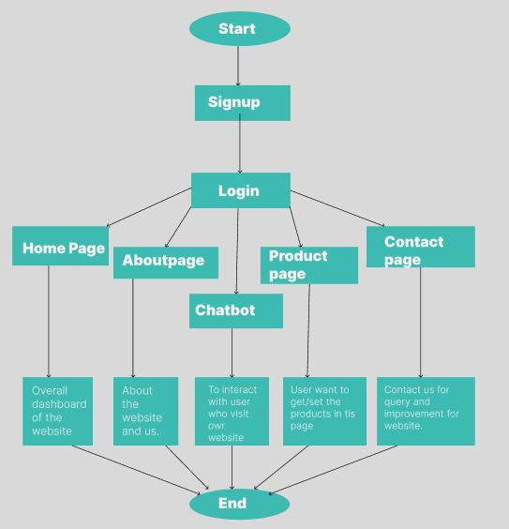

**Fig.1:** Flow chart for goods Management System.

Data processing is integral to a gift loop, involving the collection, integration, and analysis of data from various stages in the supply chain.

First, the user has to sign up and register. Next we login into our website. After login it will navigate to the homepage. If the user wants to donate product, they have to provide details about the product name, details of the product,contact details and the location by using set option. Users can also donate product. If the user wants to receive product, then they can get product by get option. If users have any doubts, they can clarify their doubts by using profile card in about page to contact us. In the contact page users can send the queries or feedbacks for the improvement.

1. **PHP**

PHP is a server scripting language, and a powerful tool for making dynamic and interactive Web pages. PHP is a widely-used, free, and efficient alternative to competitors such as Microsoft's ASP. PHP is a programming language used to script websites that are dynamic and interactive. You'll find it in various types of web applications, from e-commerce websites to CRM systems like HubSpot and Salesforce. The term PHP stands for PHP Hypertext Preprocessor.

1. **MySQL**

MySQL is a relational database management system based on SQL – Structured Query Language. The application is used for a wide range of purposes, including data warehousing, e-commerce, and logging applications. The most common use for MySQL however, is for the purpose of a web database. MySQL is used to store data in tables that map to objects. Each table has a schema defining what columns each row of the table will have. Developers can reliably store and retrieve many data types, including text, numbers, dates, times, and even JSON.

1. **HTML**

HTML stands for Hyper Text Markup Language. It is the standard markup language for creating Web pages.HTML describes the structure of a Web page, it consists of a series of elements.HTML elements tell the browser how to display the content.HTML elements label pieces of content such as "this is a heading", "this is a paragraph", "this is a link", etc.

1. **CSS**

CSS stands for Cascading Style Sheets, and it's used to add style to a web page by dictating how a site is displayed on a browser. CSS is unique in that it doesn't create any new elements, like HTML or JavaScript. Instead, it's a language used to style HTML elements.

1. **JavaScript**

JavaScript is a scripting language used to develop web pages. Developed in Netscape, JS allows developers to create a dynamic and interactive web page to interact with visitors and execute complex actions. It also enables users to load content into a document without reloading the entire page.

**FUNCTIONAL REQUIREMENTS**

***User:***

**Step 1:** First, the user has to sign up and register.

**Step 2:** Go to the homepage.

**Step 3:** If the user wants to donate product, they can donate by using donation page.

* If the user wants to donate product, they have to provide details about the product name, details about product, and the location they are in (contact details).
* If they want to help people (who are not having the product that daily needed), they have to provide details and then collect the product to donate.
* Users can also donate product that they not need anymore,so they can donate using own website.

***Admin:***

**Step 1:** First, register.

**Step 2:** Check/handle the details provided by the user.

**Step 3:** Be the mediator for the user. If they have any queries, clarify their doubts.

***Delivery:***

**Step 1:** If the user wants to receive product directly, they can do so.

**RESULT AND ANALYSIS**

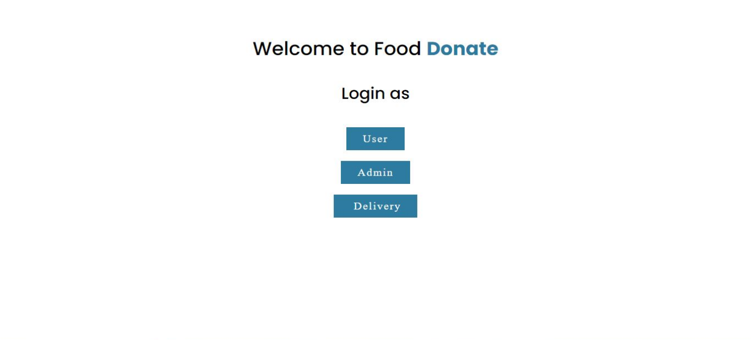

**Fig.2:** Index page

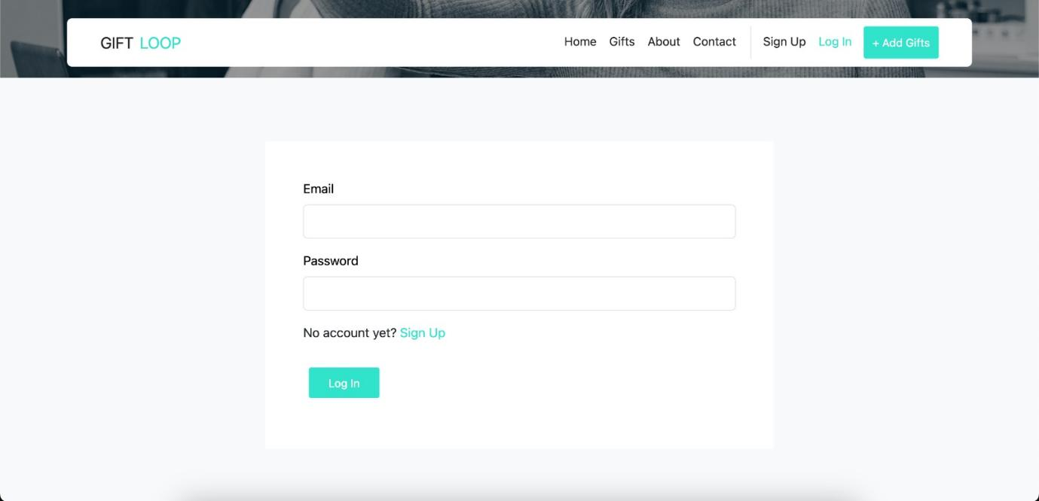

**Fig.3:** Signup page for admin

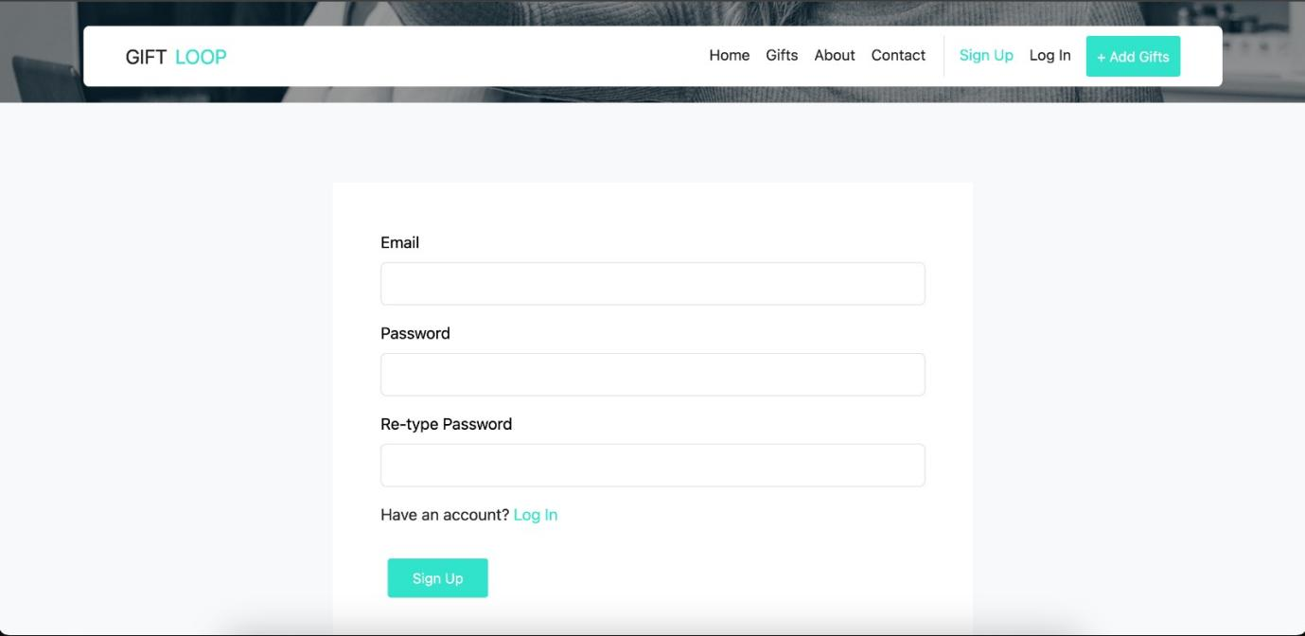

**Fig.4:** Login page for user.

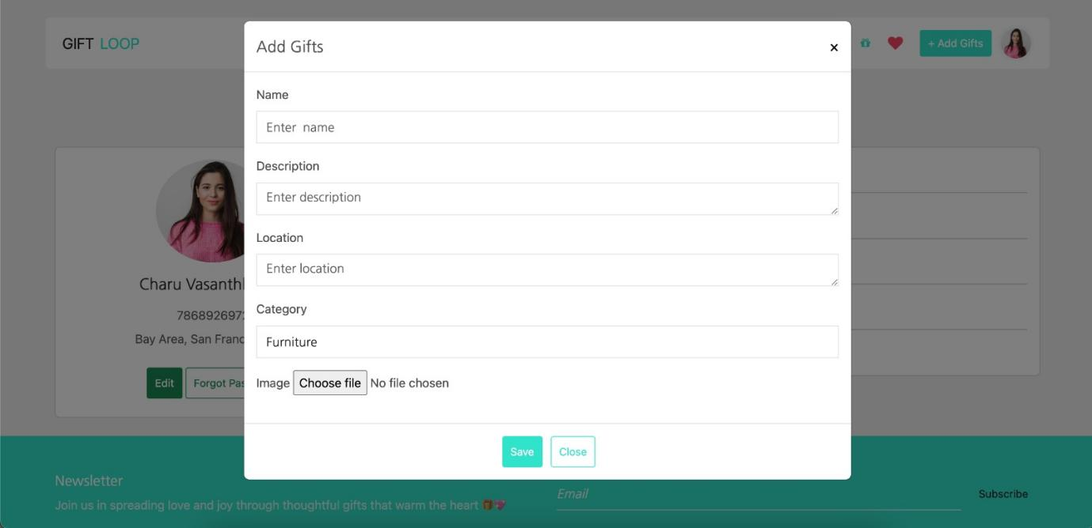

**Fig.5:** Add gifts page

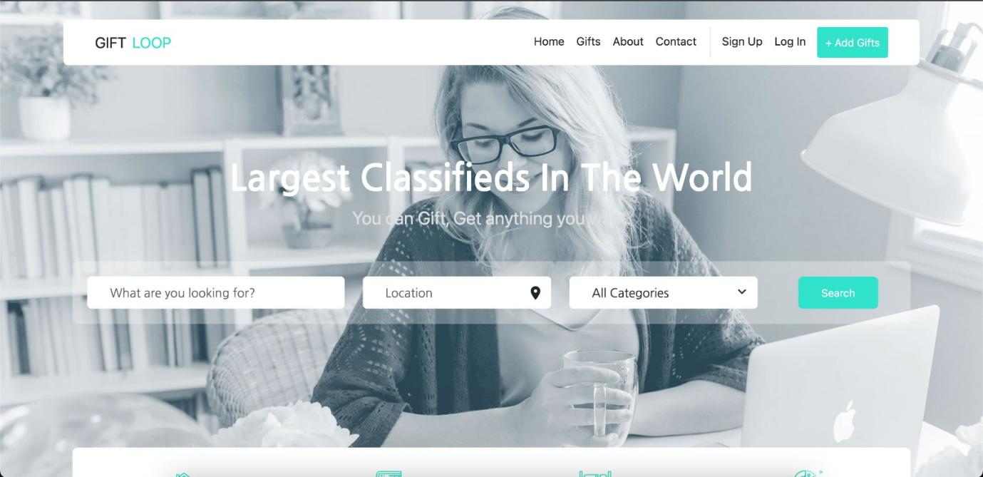

**Fig.6:** Home Page.

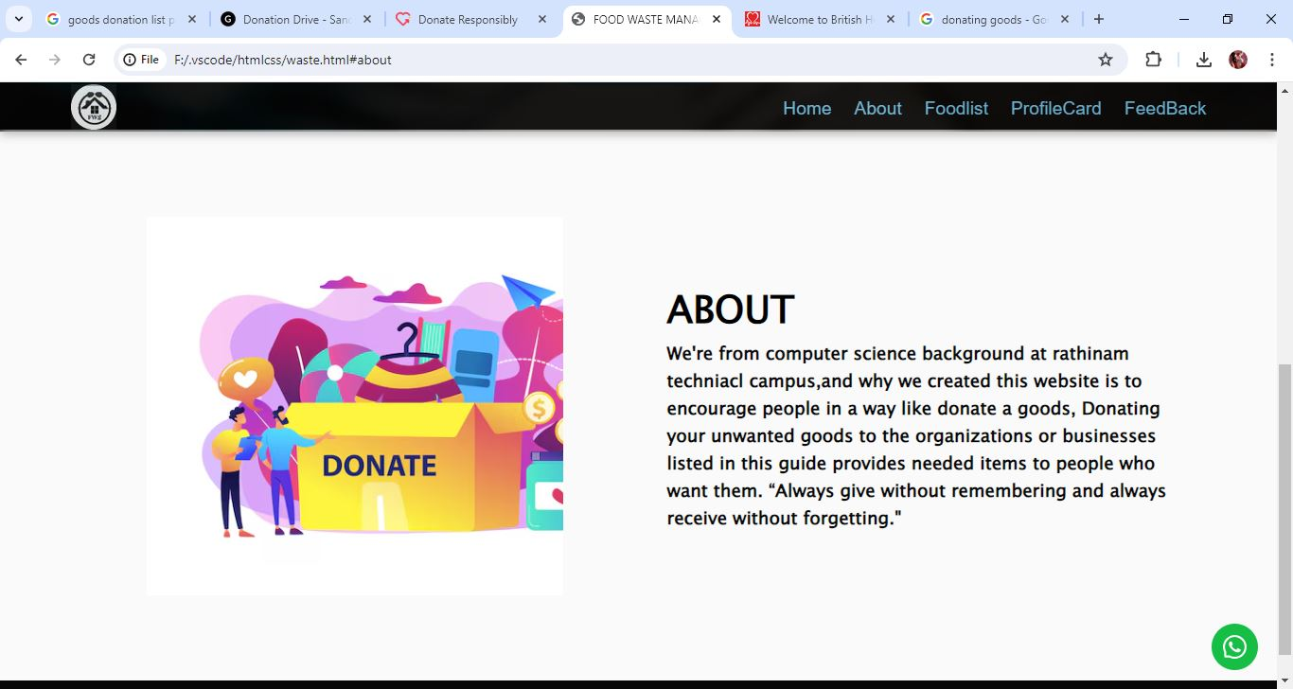

**Fig.7:** About page.

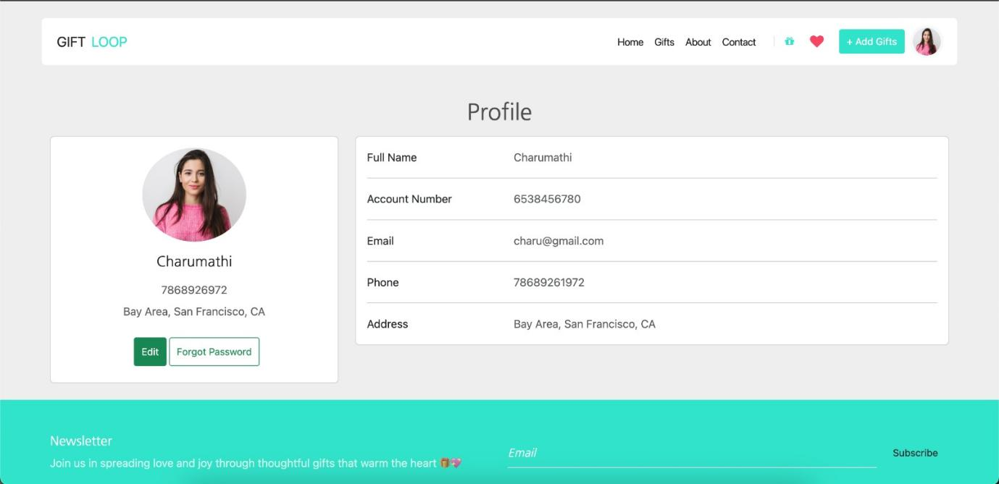

**Fig.8:**  Profile page.

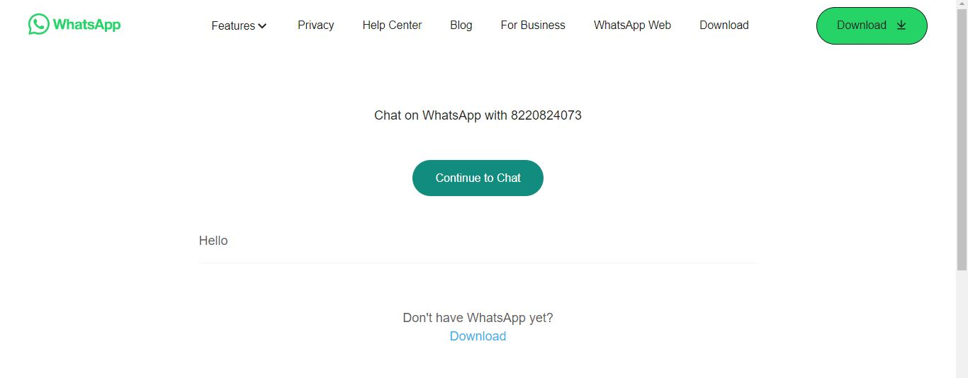

**Fig9:** For Query page.

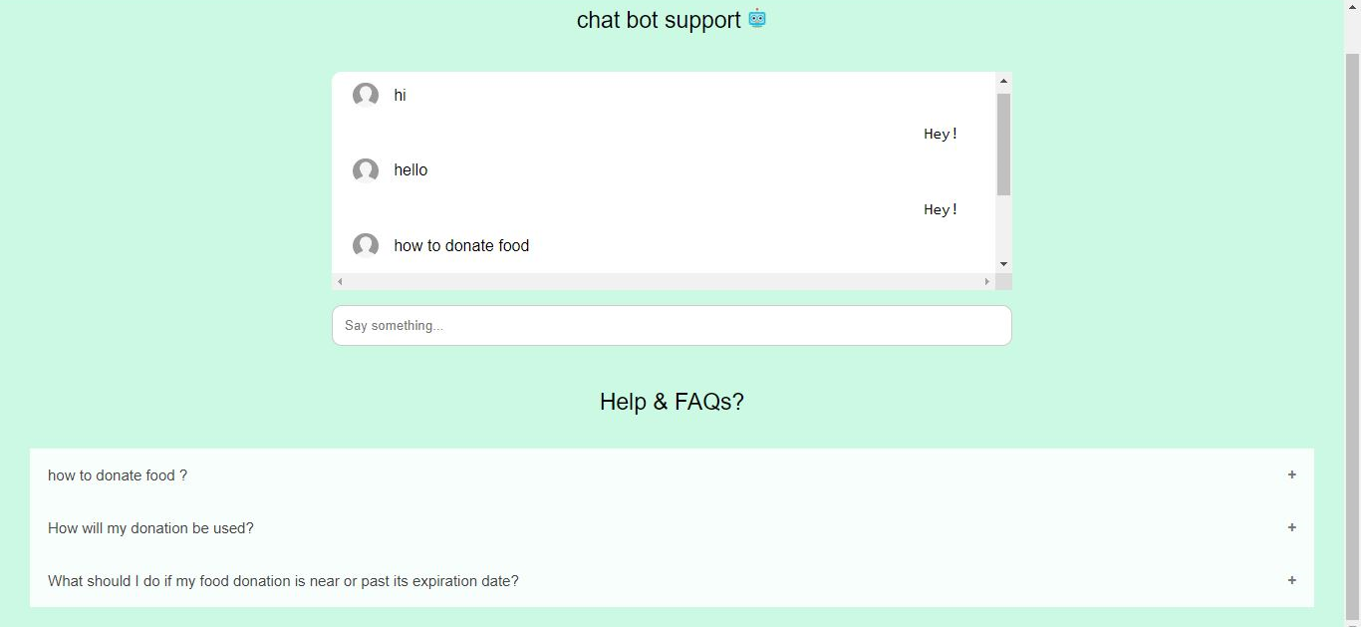

**Fig.10:** ChatBot page

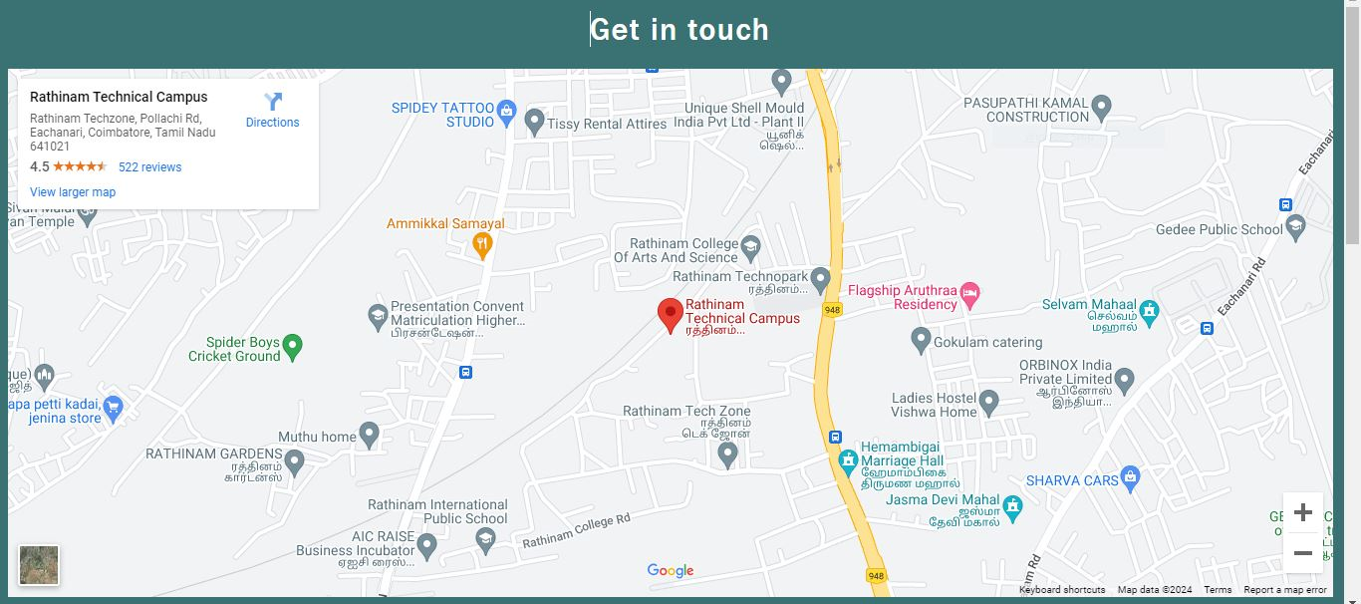

**Fig.11:** Contact page

**CONCLUSION**

Implementing an effective goods management system is imperative for addressing the environmental, social, and economic challenges associated with goods waste. By adopting sustainable practices at various stages of the supply chain, from production and distribution to consumption and disposal, we can significantly reduce the negative impacts on the environment, conserve resources, and alleviate societal issues related to poverty and inequality. In summary, an approach to goods waste management is essential for building a more sustainable and resilient system. Through collective efforts, we can mitigate the environmental impact of goods waste, address social issues, and contribute to a more equitable and sustainable future for all.

**REFERENCES**

[1] Wang, I. K., Qian, L., & Lehrer, M. (2017). From technology race to technology marathon: A behavioral explanation of technology advancement. European Management Journal, 35(2), 187-197. [2] Bruch, C., Muffett, C., & Nichols, S. S. (Eds.). (2016). Governance, Natural Resources andPost-Conflict Peacebuilding. Routledge. .

[3] Bock, D. E., Eastman, J. K., & Eastman, K. L. (2018). Encouraging consumer charitable behavior: The impact of charitable motivations, gratitude, and materialism. Journal of Business Ethics, 150(4), 1213-1228.

[4] Sarrab, M., Al-Shihi, H., Al-Khanjari, Z., & Bourdoucen, H. (2018). Development of mobile learning application based on consideration of human factors in Oman. Technology in Society, 55, 183-198

. [5] Zhong, Z. J., & Lin, S. (2018). The antecedents and consequences of charitable donation heterogeneity on social media. International Journal of Nonprofit and Voluntary Sector Marketing, 23(1), e1585

1. Liu, L., Suh, A., & Wagner, C. (2018). Emphathy or perceived credibility? an empirical study on individual donation behaviour in charitable crowdfunding. Internet Researchm, 28(3), 623-651
2. Liu, L., Suh, A., & Wagner, C. (2017). Donation behavior in online micro charities: an investigation of charitable crowdfunding projects. In Proceedings of the 50th Hawaii International Conference on System Sciences
3. Kasif, M., Sarifuddin, S., & Hassan, A. (2015). Charity donation: intentions and behaviour. Marketing Intelligence and Planning, 33(1), 90-102
4. Korolov, R., Peabody, J., Lavoie, A., Das, S., Magdon-Ismail, M., & Wallace, W. (2016). Predicting charitable donations using social media. Social Network Analysis and Mining, 6(1), 31.

[10] Wallace, E., Buil, I., & Chernatony, L. (2017). When des “liking” a charity lead to donation behaviour”: exploring conspicous donation behaviour on social media platforms. European Journal of Marketing, 51(11/12), 2002-2029 [11] Lu, S., Deng, G., Huang, C. C., & Chen, M. (2018). External environmental change and transparency in grassroots organizations in China. Nonprofit.